**WHITE BLOOD CELL DETECTION USING YOLO**

**MINOR PROJECT REPORT**

***Submitted in partial fulfilment of th*e *requirements for the award of the degree of***

**BACHELOR OF TECHNOLOGY**

***in***

**COMPUTER SCIENCE & ENGINEERING**

***by***

**BVSK Kaushik Sameer Kumar Bobby Kumar Varun Kumar Gautam**

**02015002721 02315002721 02515002721 00215002721**

***Guided by***

**Dr. Priyanka Nandal,**

**Associate Professor, CSE Department**



**DEPARTMENT OF COMPUTER SCIENCE & ENGINEERING MAHARAJA SURAJMAL INSTITUTE OF TECHNOLOGY**

**(AFFILIATED TO GURU GOBIND SINGH INDRAPRASTHA UNIVERSITY, DELHI) DELHI – 110058**

**November 2024**

**CANDIDATE’S DECLARATION**

It is hereby certified that the work which is being presented in the B. Tech Minor Project Report entitled **"WHITE BLOOD CELL DETECTION USING YOLO"** in partial fulfilment of the requirements for the award of the degree of **Bachelor of Technology** and submitted in the **Department of Computer Science & Engineering** of **MAHARAJA SURAJMAL INSTITUTE OF TECHNOLOGY, New Delhi (Affiliated to Guru Gobind Singh Indraprastha University, Delhi)** is an authentic record of our own work carried out during a period from **August 2024 to November 2024** under the guidance of **Dr. Priyanka Nandal, Associate Professor.**

The matter presented in the B. Tech. Minor Project Report has not been submitted by me for the award of any other degree of this or any other Institute.

**BVSK Kaushik Sameer Kumar**

**En. No: 02015002721 En. No: 02315002721**

**Bobby Kumar Varun Kumar Gautam**

**En. No: 02515002721 En. No: 00215002721**

**CERTIFICATE**

This is to certify that the above statement made by the candidate is correct to the best of my knowledge. He/She/They are permitted to appear in the External Minor Project Examination

**Dr. Priyanka Nandal**

**Associate Professor, Project Mentor**

**Dr. Shaily Malik**

**Assistant Professor, Project Coordinator**

**Dr. Geetika Dhand**

**HoD, CSE**

**ACKNOWLEDGEMENT**

We express our deep gratitude to **Dr. Priyanka Nandal**, Designation, Department of Computer Science & Engineering for her valuable guidance and suggestion throughout my project work. We are thankful to **Dr. Priyanka Nandal, Dr. Geetika Dhand, Dr. Shaily Malik,** Project Coordinators, for their valuable guidance.

We would like to extend my sincere thanks to **Head of the Department, Dr. Geetika Dhand** for her time-to-time suggestions to complete my project work.

**BVSK Kaushik Sameer Kumar**

**En. No: 02015002721 En. No:02315002721**

**Bobby Kumar Varun Kumar Gautam**

**En. No: 02515002721 En. No: 00215002721**

**Table of Contents**

|  |  |
| --- | --- |
| **Title Page** | **i** |
| **Candidate Declaration** | **ii** |
| **Certificate** | **iii** |
| **Acknowledgement** | **iv** |
| **Table of Contents** | **v** |
| **List of Figures** | **vi** |
| **Abstract** | **vii** |
|  |  |
| **Chapter 1: Introduction** | **8** |
| 1.1 Significance of White Blood Cell Detection | **8** |
| 1.2 Role of Artificial Intelligence | **9** |
| 1.3 Introduction to YOLO | **10** |
| 1.4 Objectives | **11** |
| 1.5 Summary | **12** |
|  |  |
| **Chapter 2: Literature Survey** | **13** |
|  |  |
| **Chapter 3: Research Methodology** | **17** |
| 3.1 Dataset Collection and Preparation | **17** |
| 3.2 Model Configuration | **20** |
| 3.3 Training the Model | **21** |
|  |  |
| **Chapter 4: Results and Discussion** | **23** |
| 4.1 Overview | **23** |
| 4.2 Training Graphs and Images | **23** |
| 4.3 Test Results | **29** |
|  |  |
| **Chapter 5: Conclusion and Future Scope** | **31** |
| 5.1 Future Scope | **31** |
|  |  |
| **References** | **33** |

**List of Figures**

|  |  |
| --- | --- |
| Figure 1.1 | Sample image from BCCD dataset |
| Figure 1.2 | Sample YOLO prediction |
| Figure 3.1 | Comparison of YOLOv10 to previous versions |
| Figure 3.2 | Label distribution in the dataset |
| Figure 3.3 | Sample data.yml |
| Figure 3.4 | Sample directory structure |
| Figure 3.5 | Our configuration |
| Figure 3.6 | Excerpts from training (a) |
| Figure 3.7 | Excerpts from training (b) |
| Figure 3.8 | Excerpts from training (c) |
| Figure 4.1 | Training results overview |
| Figure 4.2 | Training losses, precision, recall and mAP graphs |
| Figure 4.3 | F1-Confidence Curve |
| Figure 4.4 | Precision-Confidence Curve |
| Figure 4.5 | Recall-Confidence Curve |
| Figure 4.6 | Precision-Recall Curve |
| Figure 4.7 | Some training images |
| Figure 4.8 | Some validation images |
| Figure 4.9 | Some prediction images corresponding to the validation images |
| Figure 4.10 | Some prediction images (a) |
| Figure 4.11 | Some prediction images (b) |
| Figure 4.12 | Some prediction images (c) |
| Figure 4.13 | Some prediction images (d) |

**ABSTRACT**

In this project we seek to detect and classify blood cells into the types White Blood Cells (WBCs), Red Blood Cells (RBCs), and platelets in a microscopic blood smear image. For this, we will be using the latest version of YOLO which is a real time object detection and image segmentation model and train it on a custom dataset of annotated microscopic blood smeared images for our purposes. We will be using the latest version at the time which is the version 10. After this we evaluate the performance of this model and how it detects and classifies the different types of blood cells.

**CHAPTER 1: INTRODUCTION**

* 1. **Significance of White Blood Cell Detection**

White blood cells (WBCs), also known as leukocytes, are a crucial component of the immune system and play a vital role in defending the body against infections, diseases, and foreign invaders. Unlike red blood cells, which carry oxygen, white blood cells are responsible for identifying and eliminating harmful pathogens, such as bacteria, viruses, and other microorganisms. The detection, counting, and analysis of white blood cells in blood samples are essential diagnostic tasks in medicine, as abnormalities in WBC count and behavior can indicate a range of health conditions.

White blood cell detection holds significant importance in the diagnosis and monitoring of various diseases, including:

* Infections: An increase in the number of white blood cells, known as leukocytosis, is often a sign of an ongoing infection. By detecting and quantifying WBCs, healthcare providers can assess the body’s immune response and identify potential bacterial, viral, or fungal infections.
* Leukemia and Blood Disorders: Abnormalities in the types, numbers, or distribution of white blood cells can be indicative of hematological cancers like leukemia, lymphoma, or myelodysplastic syndromes. Accurate detection and classification of WBCs are crucial for early diagnosis, prognosis, and treatment decisions in these conditions.
* Autoimmune Diseases: Conditions like rheumatoid arthritis, lupus, and other autoimmune disorders can lead to alterations in white blood cell function and count. Detecting these changes is important for monitoring disease progression and therapeutic responses.
* Immune System Disorders: Conditions such as immunodeficiency or overactive immune responses often manifest through changes in WBC behavior. Early detection of these anomalies helps in understanding the underlying issues with immune regulation.
* Treatment Monitoring: For patients undergoing chemotherapy or immunosuppressive therapy, frequent monitoring of white blood cell counts is essential to assess the impact of treatment and to avoid complications such as infections, which can arise due to low white blood cell counts (leukopenia).

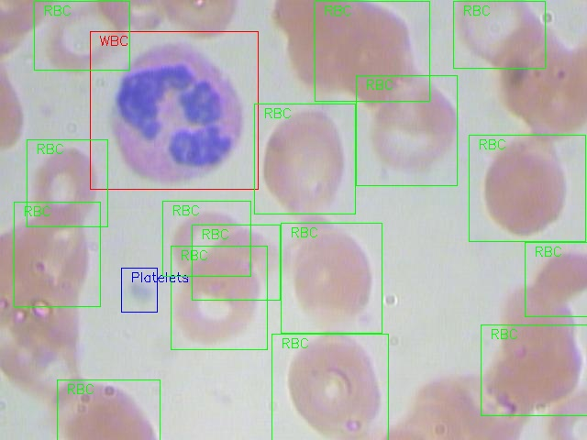

**Fig. 1.1: Sample image from BCCD dataset**

* 1. **Role of Artificial Intelligence**

Traditionally, the analysis of white blood cells involves manually examining blood smears under a microscope, a process known as a differential blood count. This method, while effective, is time-consuming, subject to human error, and can be inconsistent, especially when large numbers of samples need to be processed.

The ability to automatically detect and analyze white blood cells using advanced technologies like machine learning and computer vision offers several key advantages:

* Speed and Efficiency: Automated systems can process a large number of samples quickly, providing real-time results that enhance the speed of diagnosis.
* Accuracy and Consistency: Machine learning models, when properly trained, can consistently detect and classify white blood cells with high accuracy, reducing the likelihood of errors that could arise from manual analysis.
* Scalability: Automated systems can handle large datasets of blood samples, making them suitable for high-throughput clinical environments or research settings.
  1. **Introduction to YOLO**

You Only Look Once (YOLO [1]) is a revolutionary deep learning algorithm designed for real-time object detection. It is one of the most popular and widely used models in computer vision, known for its remarkable ability to detect and classify multiple objects in images and videos with high accuracy and speed. YOLO’s ability to perform detection in a single forward pass makes it significantly faster than previous object detection methods, while still achieving competitive performance in terms of precision and recall.

YOLO was first introduced by Joseph Redmon and his colleagues in 2015, and since then, it has evolved through several versions, with each iteration offering improvements in speed, accuracy, and efficiency. YOLO’s architecture is based on Convolutional Neural Networks (CNNs), which are particularly effective in processing image data.

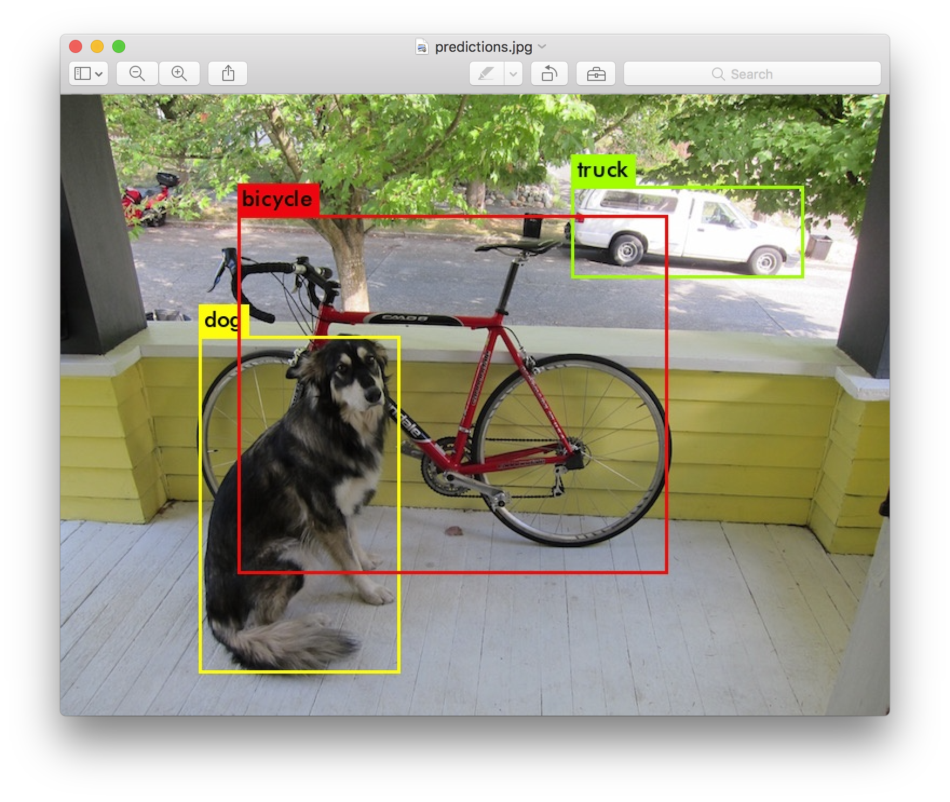

**Fig. 1.2: Sample YOLO prediction**

Key Features of YOLO:

* Single-stage Detection: Unlike traditional object detection models that use a two-stage approach (e.g., Region Proposal Networks followed by classification), YOLO performs detection in one go. It divides the input image into a grid, and each grid cell predicts bounding boxes, class probabilities, and confidence scores for objects. This end-to-end approach makes YOLO faster and more efficient, making it suitable for real-time applications.
* Real-Time Processing: YOLO is designed to process images quickly, enabling real-time object detection. This is one of its most significant advantages, making it ideal for use in applications where speed is crucial, such as autonomous vehicles, surveillance systems, and medical diagnostics.
* Global Context Understanding: YOLO processes the entire image at once, rather than looking at individual parts of the image. This helps the model to better understand the global context of an image and detect objects with more spatial consistency and fewer false positives.
* Accuracy and Precision: Although YOLO is known for its speed, it does not compromise on accuracy. The model achieves a good balance between detecting objects and minimizing false positives. Over the years, improvements in YOLO's architecture (such as YOLOv3, YOLOv4, and YOLOv5) have enhanced its ability to handle small objects, crowded scenes, and complex environments.
  1. **Objectives**

The primary goal of using YOLO (You Only Look Once) for White Blood Cell (WBC) detection is to automate and enhance the process of identifying, classifying, and counting white blood cells in blood smear images. This project aims to leverage the power of deep learning and real-time object detection to improve the efficiency, accuracy, and speed of diagnostic processes. Below are the key objectives this project aims to work towards:

* **Develop an Automated WBC Detection System:** Develop a latest YOLO-based system capable of automatically detecting white blood cells in blood smear images, reducing the need for manual inspection by pathologists.
* **Classify and Label Different Types of Blood Cells**: Train the YOLO model to not only detect but also classify different types of blood cells (red blood cells, white blood cells, and platelets) based on their shape, size, and characteristics.
* **Leverage YOLO for Real-Time Object Detection:** Implement the YOLO architecture for real-time detection of white blood cells within images, enabling efficient and fast processing.
* **Achieve High Detection Accuracy:** Train the YOLO model to achieve high accuracy in detecting various WBC types and distinguishing them from other cells or artifacts in the image.
* **Minimize False Positives and False Negatives:** Train the model to minimize false positives (incorrectly detecting objects as WBCs when they are not) and false negatives (failing to detect actual WBCs).
* **Evaluate the latest YOLO Model Performance for Blood Cell Detection:** Evaluate the performance of the YOLO-based detection system in terms of accuracy (precision, recall, F1 score), speed (frames per second), and robustness against various challenges like occlusions, image quality, and cell overlap.
* **Optimize the Model for Deployment in Clinical Environments:** Optimize the model to be deployed on real-world hardware, including edge devices, for use in clinical environments without requiring excessive computational resources.
  1. **Summary**

This project aims at training a YOLO model on a custom blood cell images dataset to segment and identify different blood cells in the image using the latest model of YOLO. We study what has already been done in the field to segment and identify the blood cells, what the latest version of YOLO offers, how it performs for blood cell detection using a basic training on a dataset.

This report delves into some of research that has happened in the field, what techniques they used to improve their models, what the base version of latest YOLO model offers us, our process of training the model on our custom dataset and then we analyze our results of how the basic training of our model improved the performance for detecting blood cells in blood smear images.

**CHAPTER 2: LITERATURE SURVEY**

S. A. Tarimo. et al, 2024 [2] proposed a 2-way approach to use two types of WBC and nucleus images. They presented a hybrid architecture that combines the strengths of YOLO and ViT. Their model attains an accuracy of 96.49% for 16 classes, including rare classes. Ablation analysis showed the value of combining object detection and ViT integration.

Y. Mao, et al, 2024 [3] proposed the DWS-YOLO blood detector, which is a lightweight blood detector. Their model includes several improved modules, including the lightweight C3 module, the increased combined attention mechanism, the Scylla-IoU loss function, and the improved soft non-maximum suppression. Improved attention, loss function, and suppression enhance detection accuracy, while lightweight C3 module reduces computation time. The experiment results demonstrated that their proposed modules can enhance a detector’s detection performance, and obtain new state-of-the-art (SOTA) results and excellent robustness performance on the BCCD dataset. On the white blood cell detection dataset (Raabin-WBC), the proposed detector’s generalization performance was confirmed to be satisfactory. Their proposed blood detector achieves high detection accuracy while requiring few computational resources and is very suitable for resource-limited but efficient medical device environments, providing a reliable and advanced solution for blood detection that greatly improves the efficiency and effectiveness of peripheral blood cell analysis in clinical practice.

A. Shakarami, et al, 2021 [4] proposed an object detector which is used for detecting blood objects such as white blood cells, red blood cells, and platelets. This detector is called FED (Fast and Efficient YOLOv3) and it is a One-Stage detector, which is similar to YOLOv3, performs detection in three scales. For the purpose of increasing efficiency and flexibility, the proposed object detector utilizes the EfficientNet Convolutional Neural Network as the backbone effectiveness. Furthermore, the Dilated Convolution is indeed applied in order to increase receptive view of the backbone. In addition, the Depthwise Separable Convolution method is utilized to minimize the detector’s parametersand the Distance Intersection over Union is further used for bounding box regression. Besides, for increasing the performance, the Swish activation function is employed. The experiments are run on the BCCD dataset that the average precision of platelets, red blood cells, and white blood cells become 90.25%, 80.41%, and 98.92%, respectively. The results of experiments and comparisons demonstrate that the proposed FED detector is more efficient than other existing studies for blood cell detection.

Y. Guo, et al, 2023 [5] proposed and implemented the blood cell detection method based on the YOLOv5 (YOLOv5-ALT). The goal of this research was to enhance the accuracy of the detection with the YOLO techniques. This work presented the method overcomes the shortcomings of the existing method by introducing the attention mechanism in the feature channel, modifying SPP module in YOLOv5 backbone feature extraction network, and changing the bounding box regression loss function. Based on the deep learning object detection algorithm, each evaluation index is compared to evaluate the effectiveness of the model. Experimental results show that the mAP@0.5, Precision and Recall of the YOLOv5-ALT reaches 97.4%, 97.9% and 93.5%. This method was more in line with the effectiveness of the blood cell detection task.

F. Xu, et al, 2022 [6] proposed a new light-weight model based on YOLOF to solve the relatively low precision of red blood cell detection problem that the FED model faced. They make further light-weight improvements to YOLOF, reducing the model complexity to less than 10M and improving the performance of blood cell detection. For each component we used, they have done ablation experiments to prove its advantages. The proposed model TE-YOLOF can be generalized to other datasets for detection directly. It shows the great potential to achieve robustness in the field of blood cell detection.

M. Huang, et al, 2023 [7] proposed blood cell target detection algorithm based on YOLOv5 which addressed the issue of low average accuracy and serious miss detection due to small blood cells and serious cell adhesion in blood cell detection by target detection algorithms. By adding the CBAM (Convolutional Block Attention Module) to the YOLOv5 framework's backbone network and the BIFPN (bidirectional feature pyramid network) to the neck network, the algorithm improves the model's ability to extract features. The experimental results show that the average accuracy (mAP) of the improved YOLOv5 blood cell target detection algorithm is 89.9%, representing a increase over the native YOLOv5s type, and the recall rate and accuracy rate are also increased by 3.2% and 4.2%, respectively. This meets the requirements of the actual scene for blood cell detection.

W. Gu, et al, 2023 [8] proposed an improved YOLOv5 (AYOLOv5) based on the attention mechanism to address the issue of the low recognition rate of cell detection caused by this circumstance. Based on YOLOv5, the attention mechanism is introduced to improve the convolutional neural network's features in areas of the picture with a high density of features. The convolutional block attention module (CBAM) and the transformer encoder block are used in this study to develop the attention mechanism. The YOLOv5 integrated convolutional block attention module increases the weight of cell-dense regions in blood cell pictures and aids the network's ability to resist information other than cells. Additionally, the transformer block is introduced to YOLOv5′s processing of upper and lower feature data to improve the network's capacity to gather details about various cell properties, enabling AYOLOv5 to recognize and distinguish blood cells in cell-dense areas. The experiment was done on the dataset BCCD, and the mAP results for cell detection reached 93.3%, better than previously discovered. Also, the validation set's average recognition accuracy increased from 89% to 98%. The experimental results demonstrated that the suggested AYOLOv5 could extract the cells' feature information more effectively, considerably improving the cell pictures and recognition performance.

Y. Wu, et al, 2023 [9] proposes an improved target detection algorithm, SDE-YOLO, based on the YOLOv5s framework, to address the low detection accuracy, misdetection, and leakage in blood cell detection caused by existing single-stage and two-stage detection algorithms. Initially, the Swin Transformer is integrated into the back-end of the backbone to extract the features in a better way. Then, the 32 × 32 network layer in the path-aggregation network (PANet) is removed to decrease the number of parameters in the network while increasing its accuracy in detecting small targets. Moreover, PANet substitutes traditional convolution with depth-separable convolution to accurately recognize small targets while maintaining a fast speed. Finally, replacing the complete intersection over union (CIOU) loss function with the Euclidean intersection over union (EIOU) loss function can help address the imbalance of positive and negative samples and speed up the convergence rate. The SDE-YOLO algorithm achieves a mAP of 99.5%, 95.3%, and 93.3% on the BCCD blood cell dataset for white blood cells, red blood cells, and platelets, respectively, which is an improvement over other single-stage and two-stage algorithms such as SSD, YOLOv4, and YOLOv5s. The experiment yields excellent results, and the algorithm detects blood cells very well. The SDE-YOLO algorithm also has advantages in accuracy and real-time blood cell detection performance compared to the YOLOv7 and YOLOv8 technologies.

Z. Zhang, et al, 2022 [10] proposed an improved algorithm EIoU-YOLOV5 based on Yolov5, which improves the Loss function of prediction box by replacing CIoU Loss with EIoU Loss. Experimental results on the common data set BCCD show that, compared with the original Yolov5 algorithm, the Recall of EIou-YOLOV5 algorithm increased from 0.855 to 0.917, which increased by 6.2 percentage points. Therefore, it reduced the missed rate effectively. The result of mAP@0.5 is increased from 0.899 to 0.922, which is raised by 2.3 percentage points. Among them, the detection of platelet increased the most. It increased from 0.858 to 0.92, which increased by 6.2 percentage points.

M. Kang, et al, 2024 [11] proposed a CST-YOLO model for blood cell detection based on YOLOv7 architecture and enhance it with the CNN-Swin Transformer (CST), which is a new attempt at CNN-Transformer fusion. We also introduce three other useful modules: Weighted Efficient Layer Aggregation Networks (W-ELAN), Multiscale Channel Split (MCS), and Concatenate Convolutional Layers (CatConv) in our CST-YOLO to improve small-scale object detection precision. Experimental results show that the proposed CST-YOLO achieves 92.7%, 95.6%, and 91.1% mAP @ 0.5, respectively, on three blood cell datasets, outperforming state-of-the-art object detectors, e.g., RT-DETR, YOLOv5, and YOLOv7.

C. Shi, et al, 2024 [12] proposed a lightweight blood cell detection model based on YOLOv8n, named GPMB-YOLO. This model utilizes advanced lightweight strategies and PGhostC2f design, effectively reducing model complexity and enhancing detection speed. The integration of the simple parameter-free attention mechanism (SimAM) significantly enhances the model’s feature extraction ability. Furthermore, they have designed a multidimensional attention-enhanced bidirectional feature pyramid network structure, MCA-BiFPN, optimizing the effect of multi-scale feature fusion. And use genetic algorithms for hyperparameter optimization, further improving detection accuracy. Experimental results validate the effectiveness of the GPMB-YOLO model, which realized a 3.2% increase in mean Average Precision (mAP) compared to the baseline YOLOv8n model and a marked reduction in model complexity. Furthermore, they have developed a blood cell detection system and deployed the model for application. This study serves as a valuable reference for the efficient detection of blood cells in medical images.

D. Zhang, et al, 2024 [13] proposed TW-YOLO approach, leveraging multi-scale feature fusion techniques. Firstly, traditional CNN (Convolutional Neural Network) convolution has poor recognition capabilities for certain blood cell features, so the RFAConv (Receptive Field Attention Convolution) module was incorporated into the backbone of the model to enhance its capacity to extract geometric characteristics from blood cells. At the same time, utilizing the feature pyramid architecture of YOLO (You Only Look Once), they enhanced the fusion of features at different scales by incorporating the CBAM (Convolutional Block Attention Module) in the detection head and the EMA (Efficient Multi-Scale Attention) module in the neck, thereby improving the recognition ability of blood cells. Additionally, to meet the specific needs of blood cell detection, they designed the PGI-Ghost (Programmable Gradient Information-Ghost) strategy to finely describe the gradient flow throughout the process of extracting features, further improving the model’s effectiveness. Experiments on blood cell detection datasets such as BloodCell-Detection-Dataset (BCD) reveal that TW-YOLO outperforms other models by 2%, demonstrating excellent performance in the task of blood cell detection. In addition to advancing blood cell image analysis research, this work offers strong technical support for future automated medical diagnostics.

**CHAPTER 3: RESEARCH METHODOLOGY**

We will be using the latest version of YOLO at the time which is the version 10[16]. YOLOv10, built on the Ultralytics Python package by researchers at Tsinghua University, introduces a new approach to real-time object detection, addressing both the post-processing and model architecture deficiencies found in previous YOLO versions. By eliminating non-maximum suppression (NMS) and optimizing various model components, YOLOv10 achieves state-of-the-art performance with significantly reduced computational overhead. Extensive experiments demonstrate its superior accuracy-latency trade-offs across multiple model scales.

The architecture of YOLOv10 builds upon the strengths of previous YOLO models while introducing several key innovations. The model architecture consists of the following components:

1. **Backbone**: Responsible for feature extraction, the backbone in YOLOv10 uses an enhanced version of CSPNet (Cross Stage Partial Network) to improve gradient flow and reduce computational redundancy.
2. **Neck**: The neck is designed to aggregate features from different scales and passes them to the head. It includes PAN (Path Aggregation Network) layers for effective multiscale feature fusion.
3. **One-to-Many Head**: Generates multiple predictions per object during training to provide rich supervisory signals and improve learning accuracy.
4. **One-to-One Head**: Generates a single best prediction per object during inference to eliminate the need for NMS, thereby reducing latency and improving efficiency.

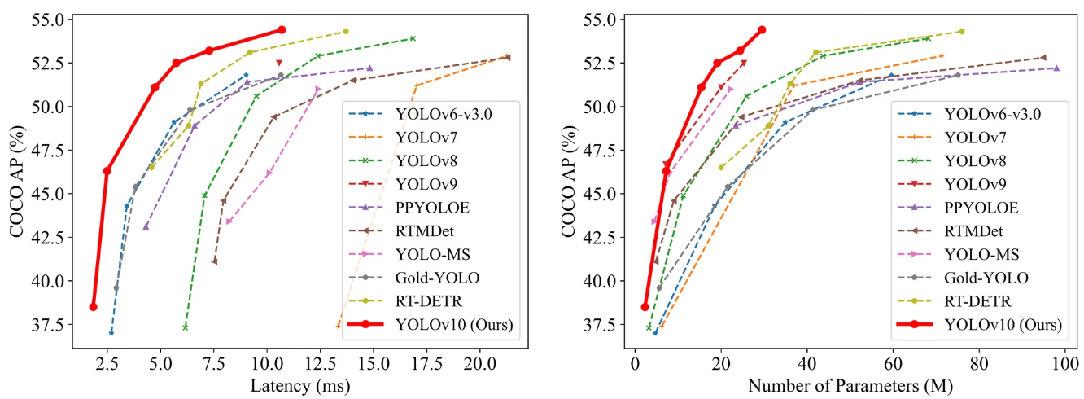

**Fig. 3.1: Comparison of YOLOv10 to previous versions**

**3.1 Dataset Collection and Preparation**

The base dataset we are using is the Blood Cell Count and Detection [14] which is available for free on Github. It is a small-scale dataset for blood cell detection.

Overview of the dataset:

* We have three kinds of labels in the dataset, i.e., WBC, RBC, and platelets.
* All images are jpeg images with a resolution of 640x480
* There are a total of 410 images in this dataset as of current.

We use another dataset[15] which is similar to this dataset except that it has images of square resolution. It is also available on Github for free. This is a dataset of blood cells photos.

There are 364 images across three classes: WBC (white blood cells), RBC (red blood cells), and Platelets. There are 4888 labels across 3 classes (and 0 null examples) with a resolution of 416x416.

The distribution of labels in the dataset:

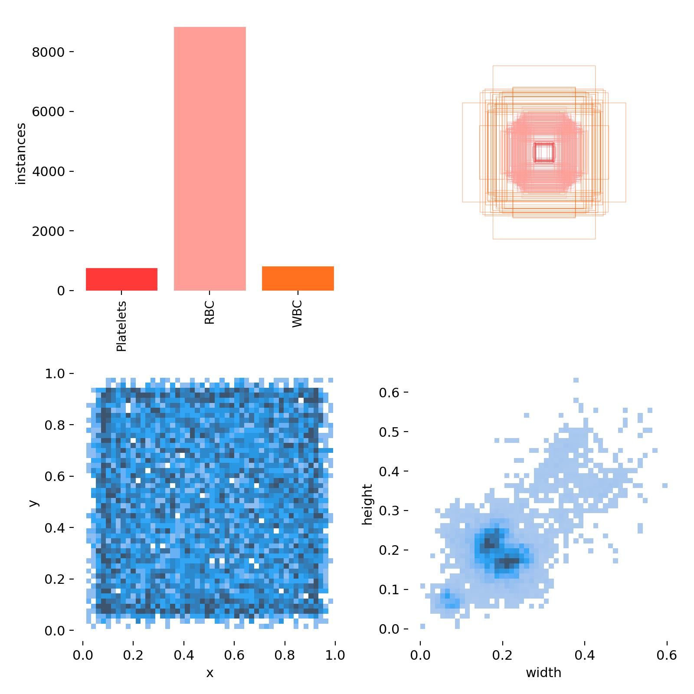

**Fig. 3.2: Label distribution in the dataset**

YOLO data format:

The Ultralytics YOLO format is a dataset configuration format that allows you to define the dataset root directory, the relative paths to training/validation/testing image directories or *.txt files containing image paths, and a dictionary of class names. Here is an example:

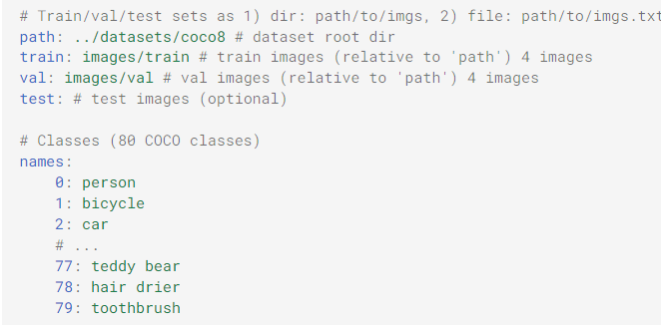

**Fig. 3.3: Sample data.yml**

Labels for this format should be exported to YOLO format with one *.txt file per image. If there are no objects in an image, no *.txt file is required. The *.txt file should be formatted with one row per object in class x_center y_center width height format. Box coordinates must be in **normalized xywh** format (from 0 to 1). If your boxes are in pixels, you should divide x_center and width by image width, and y_center and height by image height. Class numbers should be zero-indexed (start with 0).

When using the Ultralytics YOLO format, organize your training and validation images and labels as shown:

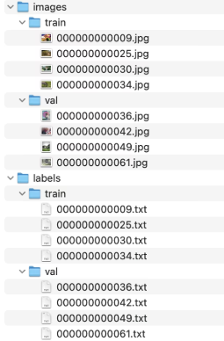

**Fig. 3.4: Sample directory structure**

**3.2 Model Configuration**

Configuring the YOLO model involved selecting an appropriate architecture variant (e.g., YOLOv9, YOLOv10) and subvariant (e.g. YOLOv10n, YOLOv10s) and tuning hyperparameters to optimize performance for blood cell detection. This included adjusting parameters such as learning rate, batch size, and the number of epochs based on the dataset's size and complexity. The model configuration also involved defining the number of classes (i.e., red blood cells, white blood cells, platelets) and setting the input image dimensions to match the dataset specifications.

We create a data.yml file as shown in the dataset preparation section above with three classes WBC, RBC, and platelets and format the data as shown:

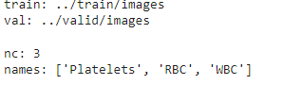

We select the YOLOv10x which is the extra large model of the YOLOv10. For our purposes we train a very basic model with few parameter changes. We select the Adam optimizer, initial learning rate of 0.1, final learning rate of 0.00001 and train our model for 150 epochs.

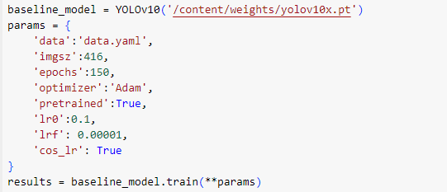

**Fig. 3.5: Our configuration**

**3.3 Training the Model**

We the train the model on T4 GPU in Google Colab for 150 epochs which took about 50 minutes. Following are some excerpts from the training process:

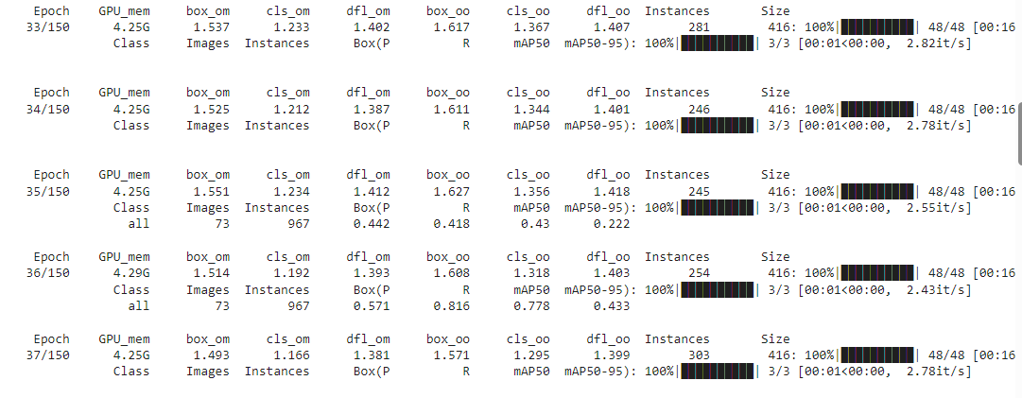

**Fig. 3.6: Excerpts from training (a)**

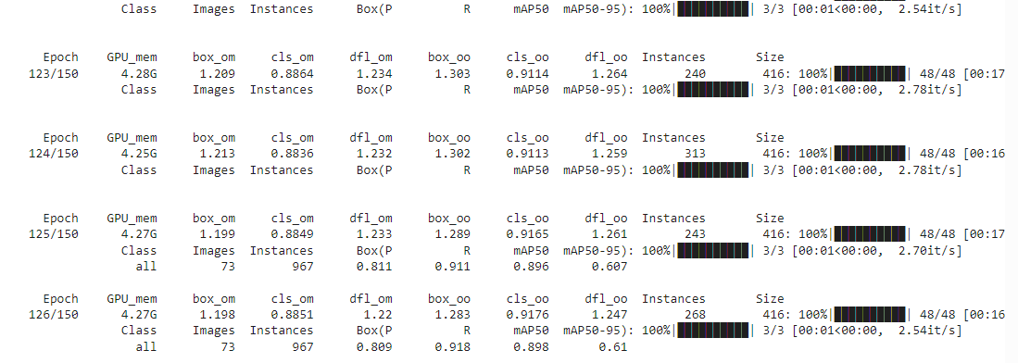

**Fig. 3.7: Excerpts from training (b)**

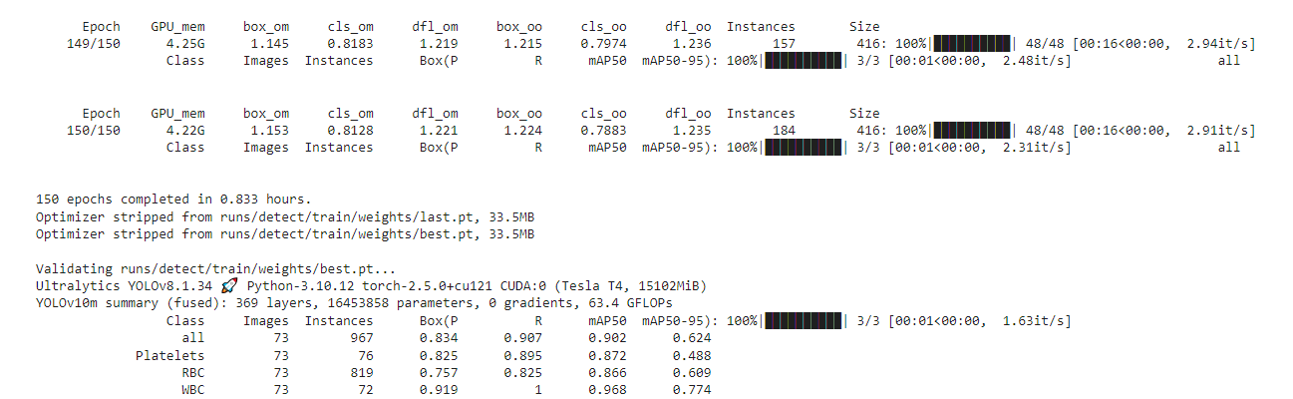

**Fig. 3.8: Excerpts from training (c)**

**CHAPTER 4: RESULTS AND DISCUSSION**

**4.1 Overview**

The training process of 150 epochs took 50 minutes to complete and resulted in mAP50 of 96.8, 86.6, 87.2 and 90.2 percent for WBC, RBC, platelets and overall, respectively.

We then use our model on test images to test our results.

Following is an overview of the results of the training process:

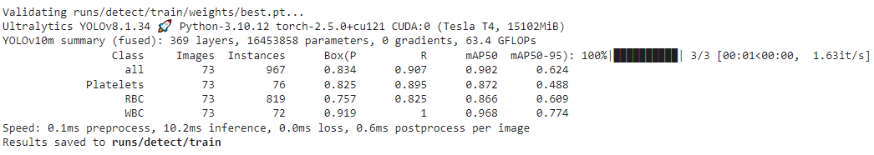

**Fig. 4.1: Training results overview**

**4.2 Training Graphs and Images**

Following are the graphs of the loss functions, precision, recall and mAP:

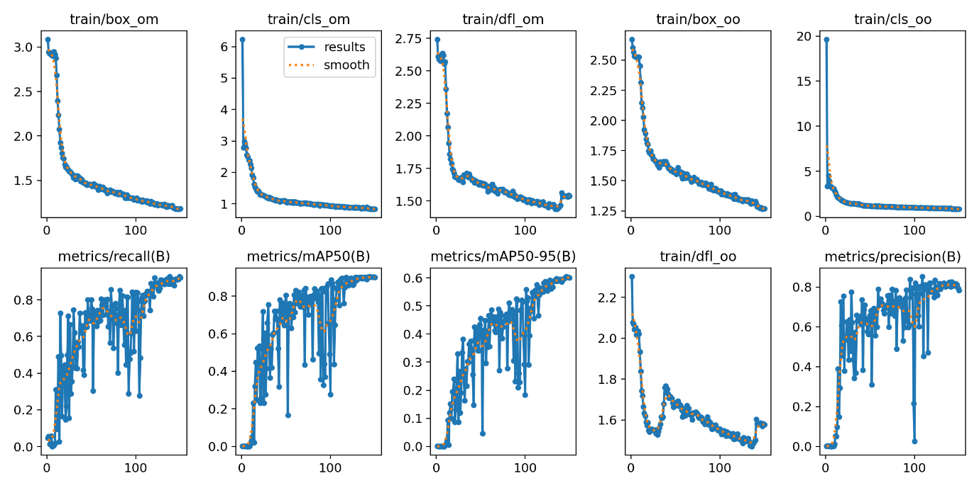

**Fig. 4.2: Training losses, precision, recall and mAP graphs**

Following are the different curves for our model:

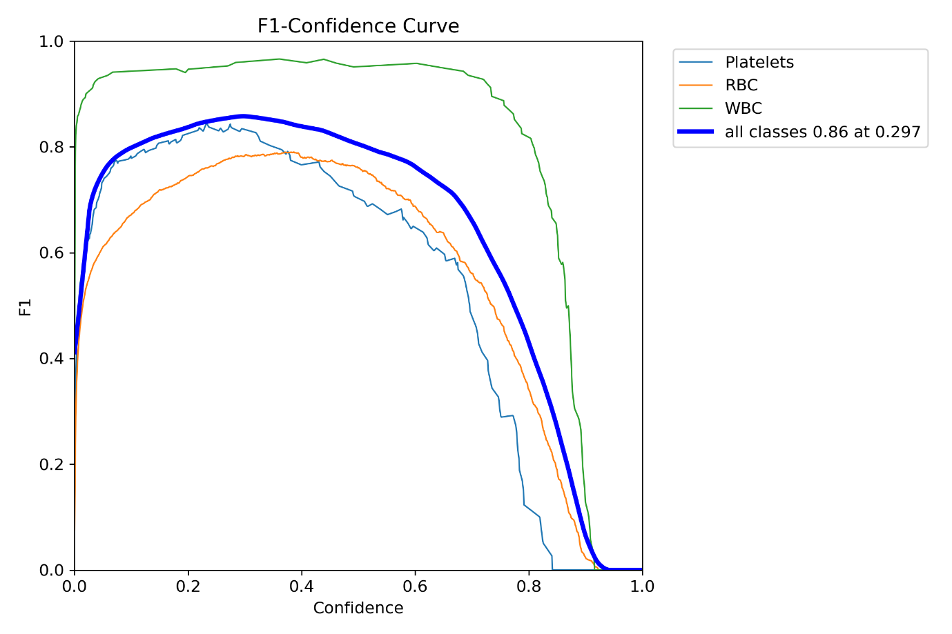

**Fig. 4.3: F1-Confidence Curve**

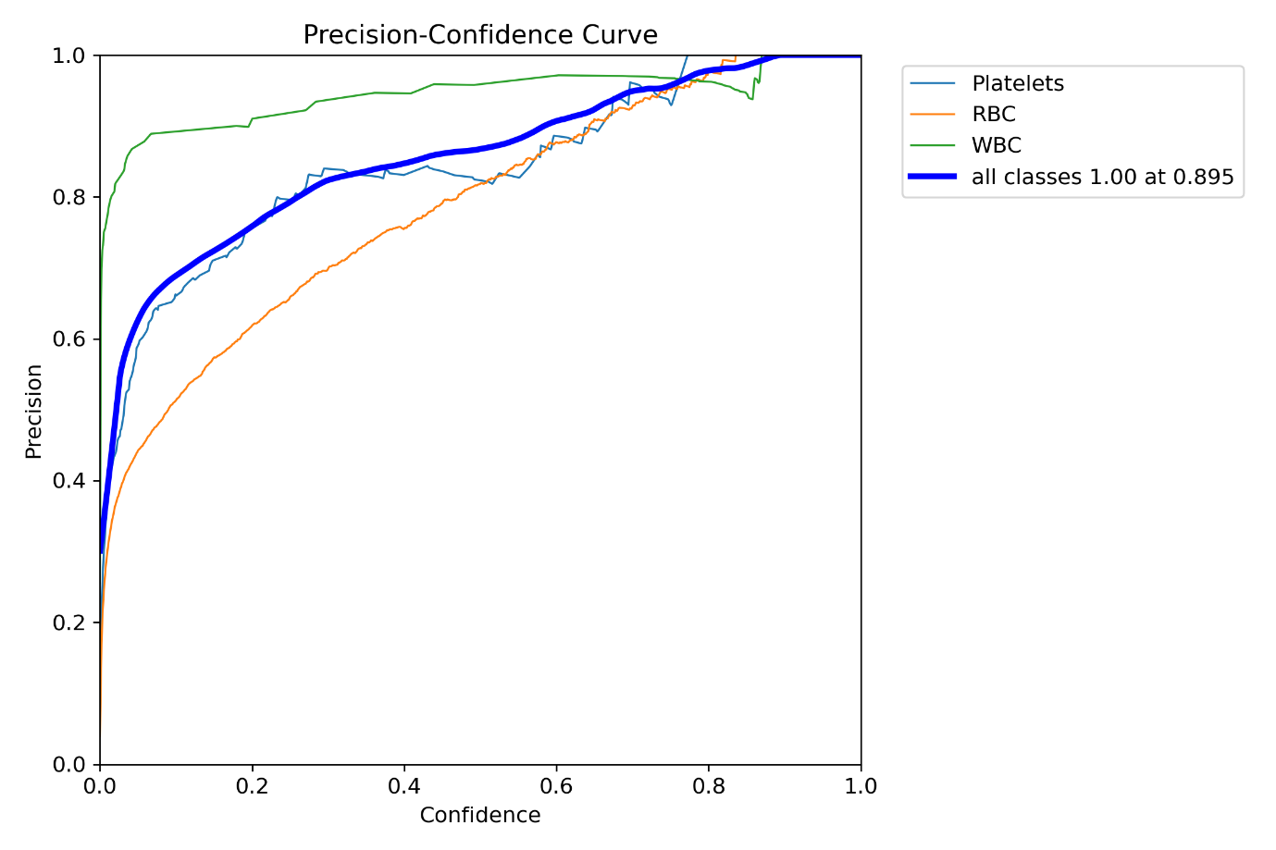

**Fig. 4.4: Precision-Confidence Curve**

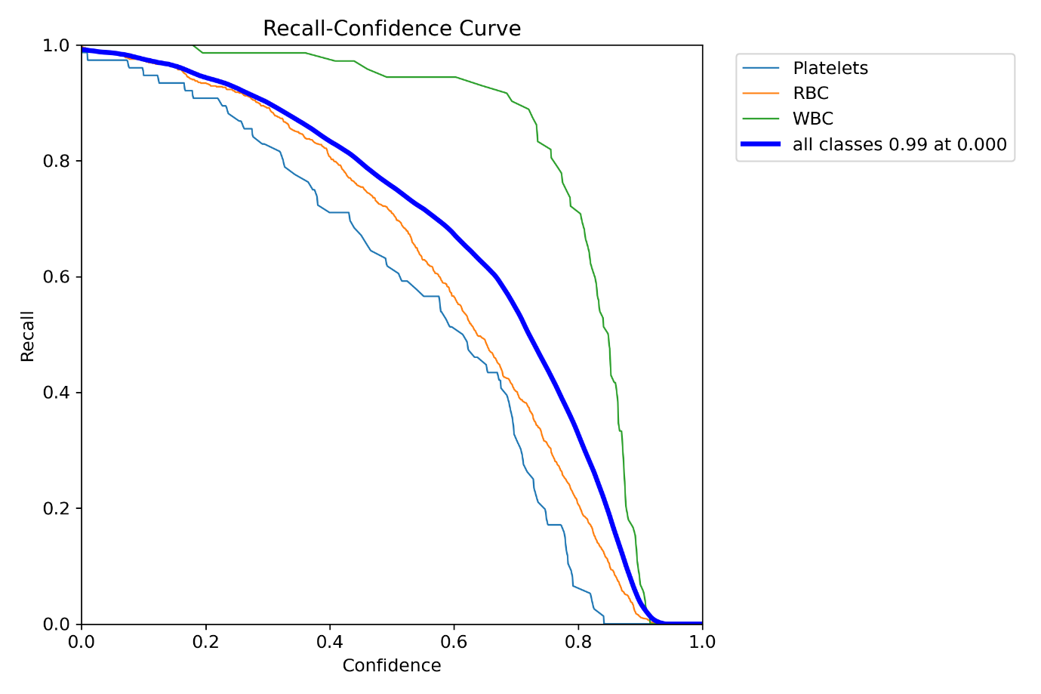

**Fig. 4.5: Recall-Confidence Curve**

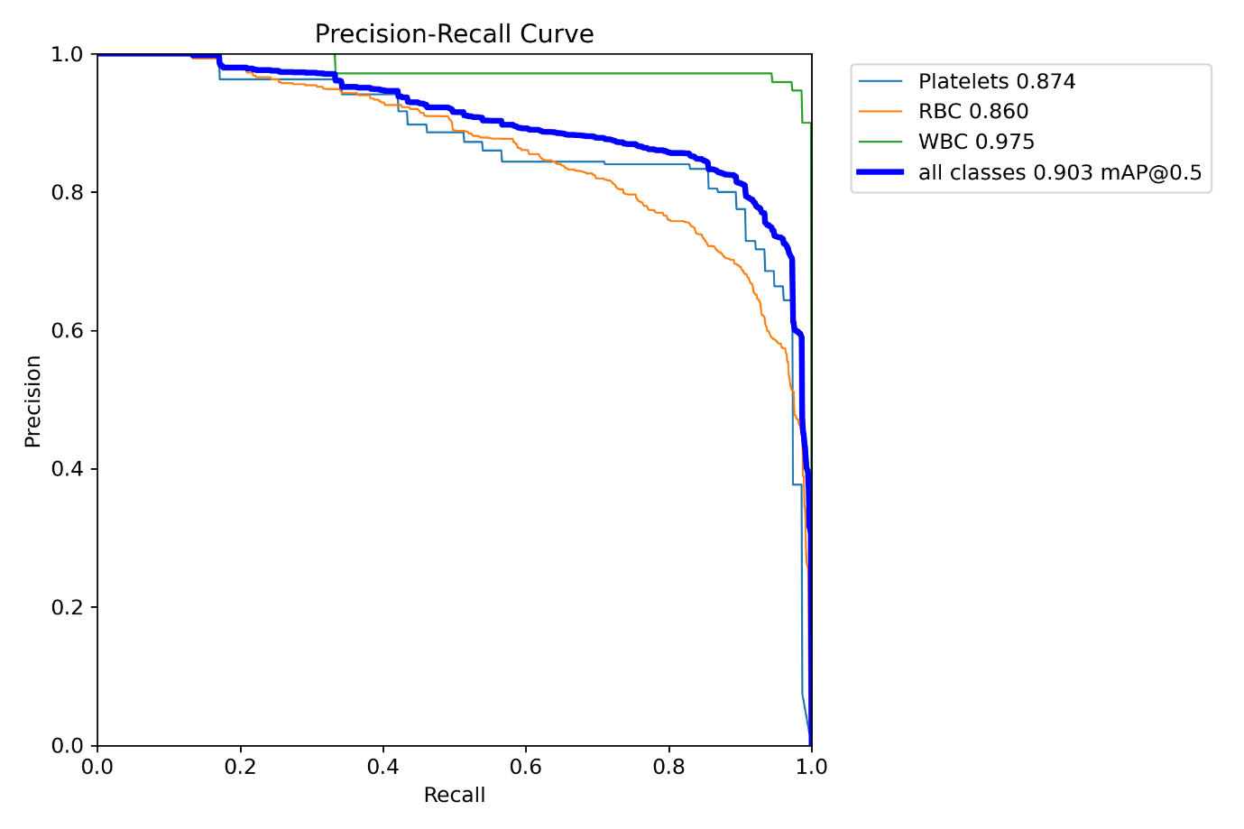

**Fig. 4.6: Precision-Recall Curve**

Some of the images during training process:

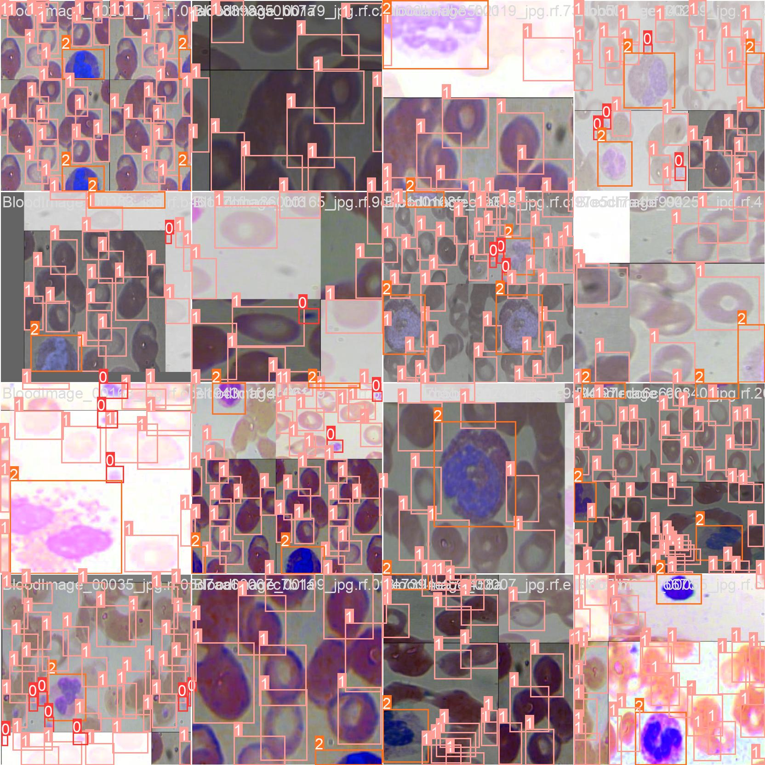

**Fig. 4.7: Some training images**

Some of the images during validation process:

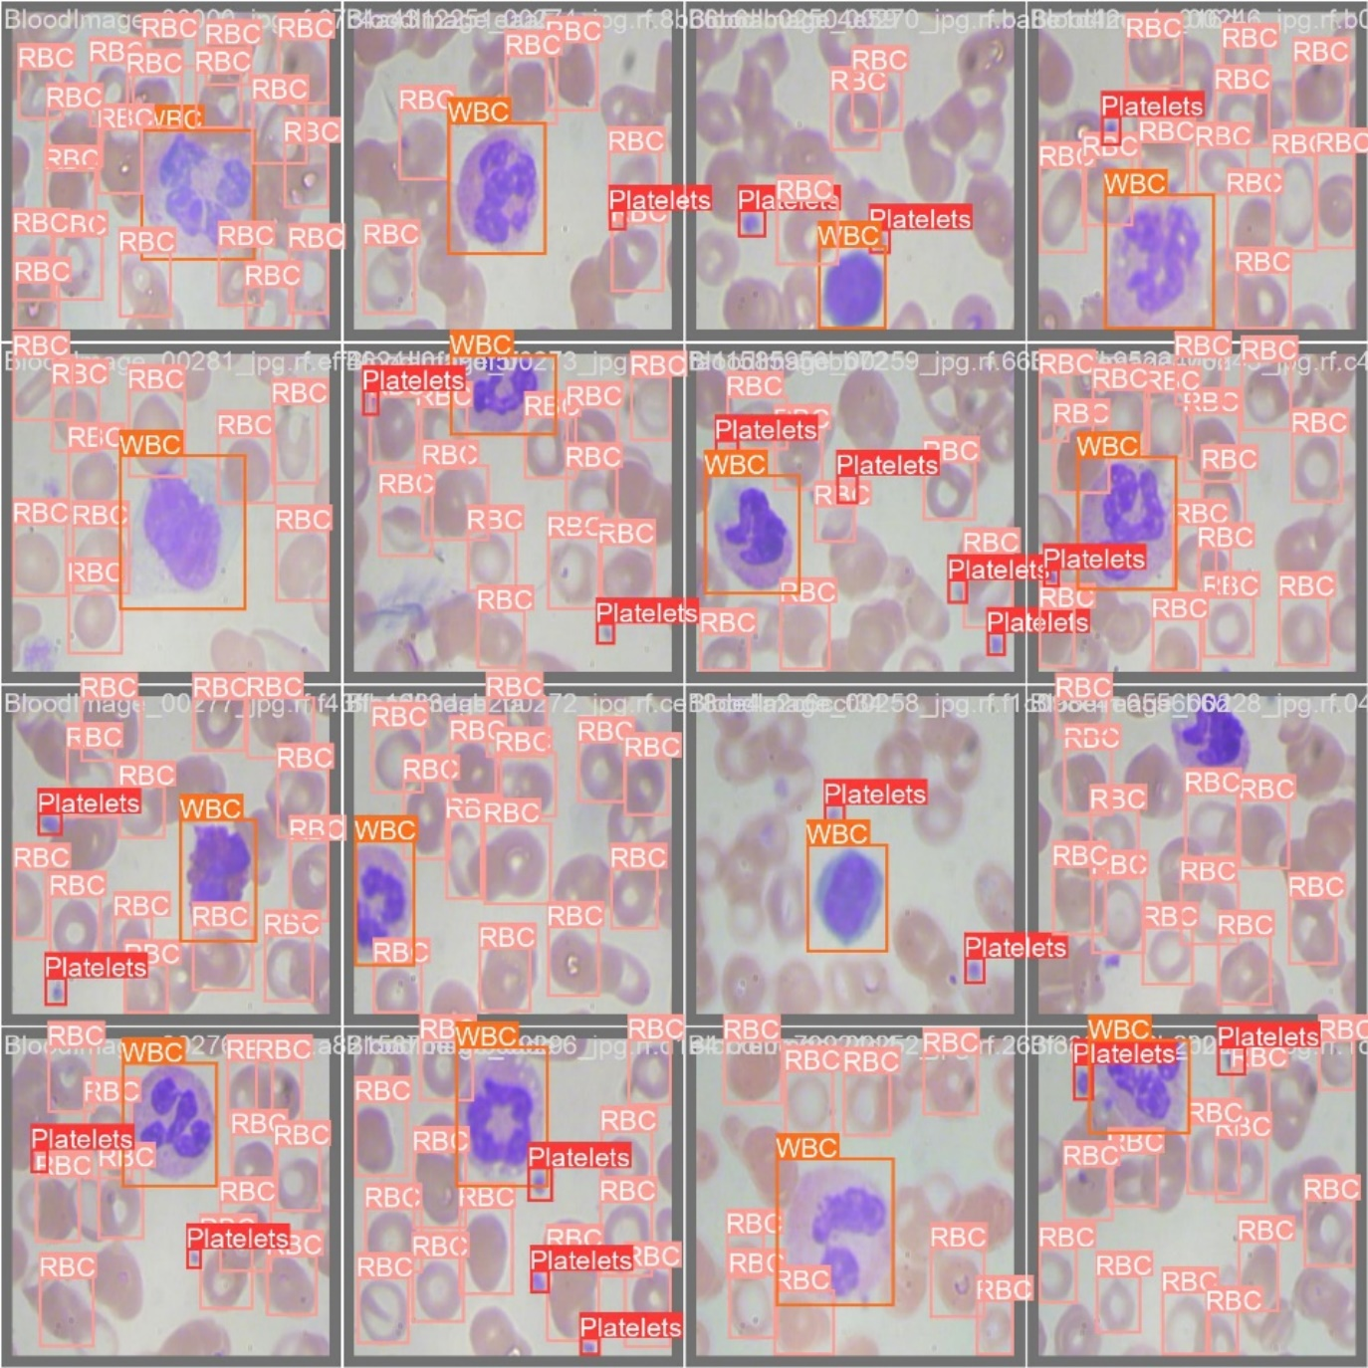

**Fig. 4.8: Some validation images**

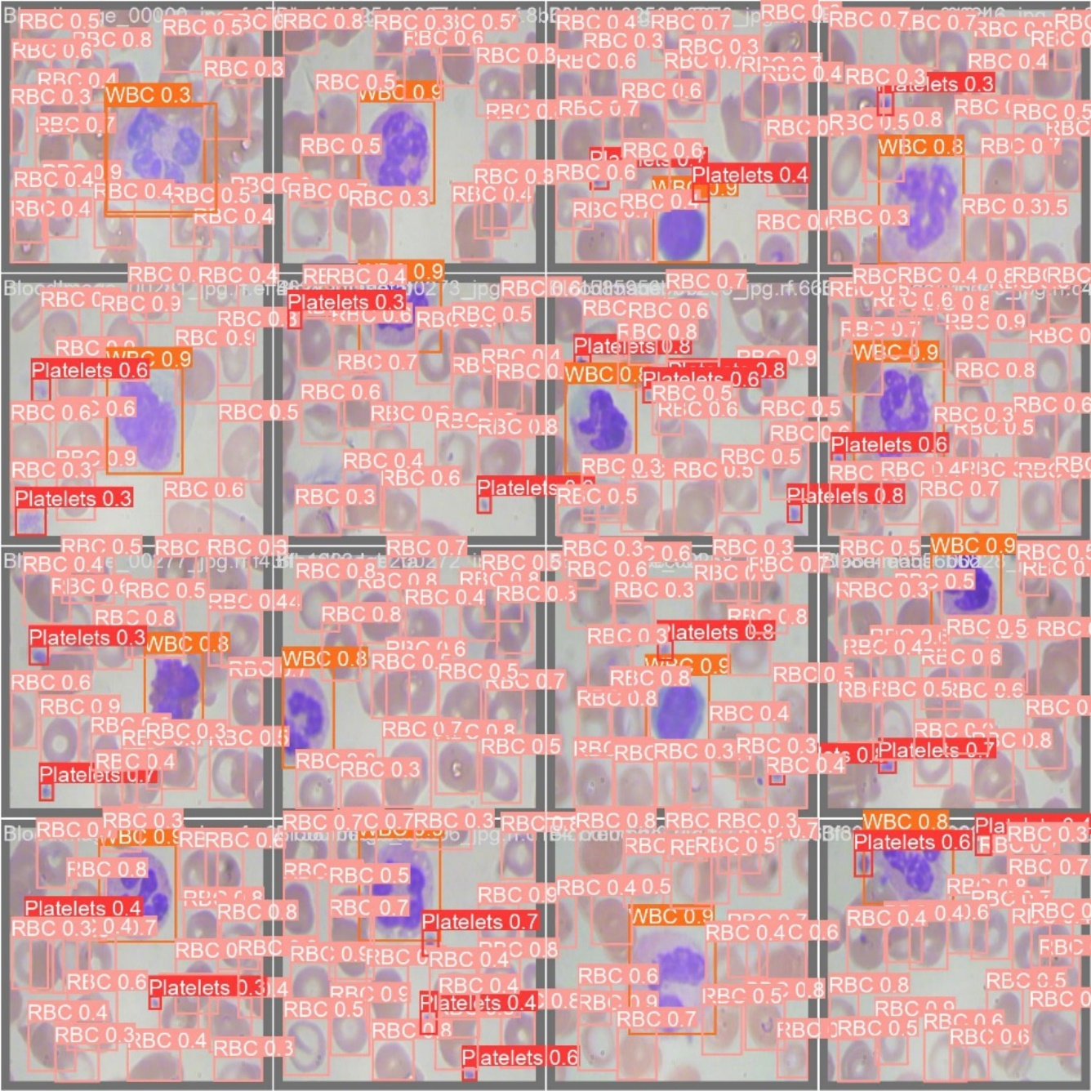

**Fig. 4.9: Some prediction images corresponding to the validation images**

**4.3 Test Results**

Some images testing the model for prediction:

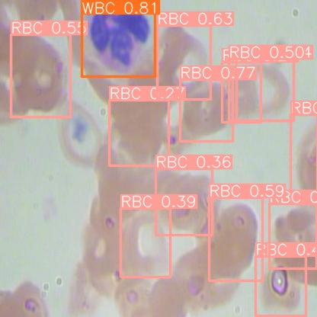 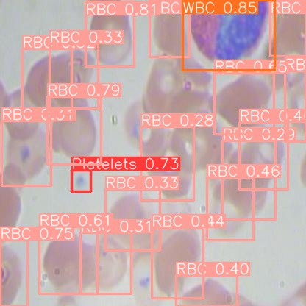

**Fig. 4.10: Some prediction images (a)**

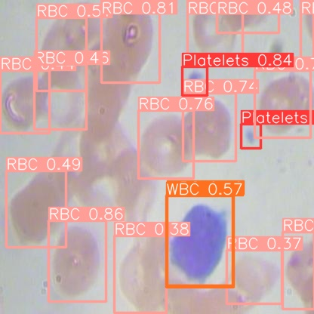 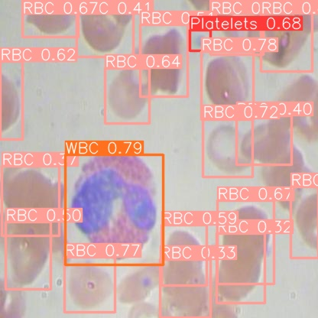

**Fig. 4.11: Some prediction images (b)**

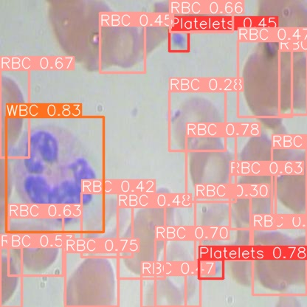 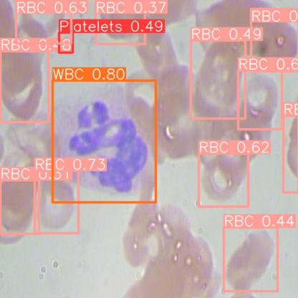

**Fig. 4.12: Some prediction images (c)**

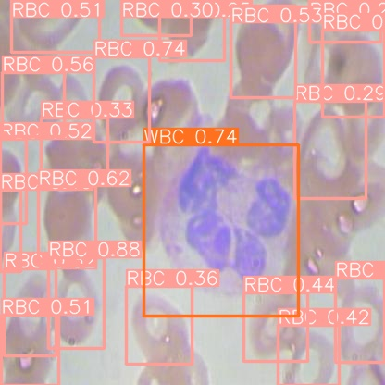 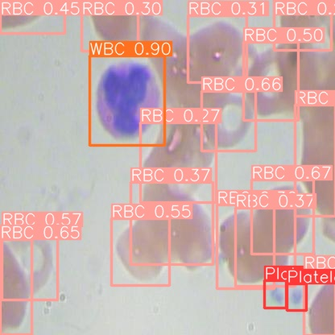

**Fig. 4.13: Some prediction images (d)**

As we can see the even with minimal training and modification the latest version of YOLO gives very good results. What we reviewed in the second chapter was that much had been done to improve the performance of YOLO for blood cell detection by modifying its structure or by adding other detection phases to the model. What we showed here is that the latest model of YOLO even with minimal configuration and minimal custom training gives us very good results which can be improved further by applying the modifications already tried on older YOLO models.

**CHAPTER 5: CONCLUSION AND FUTURE SCOPE**

There was a lot of previous research that had been done to improve the performance of YOLO for blood cell detection. The literature mentioned in the second chapter was only what we skimmed over before starting over project. There is a lot more that has been done before it. The common theme in all those was that they modified YOLO significantly either YOLO itself or by adding a different detection phase. What we demonstrated is that even without heavy modification the latest YOLO was decent for blood cell detection.

The implementation of the latest version of YOLO (You Only Look Once) for white blood cell (WBC) detection has proven to be an effective approach for automating the analysis of blood smear images. By leveraging the real-time object detection capabilities of YOLO, this project has demonstrated several key achievements:

* High Accuracy and Precision: YOLO's ability to detect white blood cells with high precision and recall in various blood smear images indicates its strong potential for accurate WBC detection. The model can distinguish between different types of white blood cells and is capable of identifying them in varying sizes and orientations.
* Real-Time Performance: The speed of YOLO in processing images, even with complex input data, allows for near real-time detection. This characteristic is especially useful in medical applications where time-sensitive decisions are crucial, such as in clinical laboratories and diagnostic settings.
* Robustness to Variability: The model's performance is relatively robust against variations in lighting, background noise, and image quality. This suggests that YOLO can be deployed across different clinical environments with minimal need for image preprocessing or adjustments.
* Potential for Clinical Integration: Integrating YOLO-based WBC detection into diagnostic workflows can significantly enhance the efficiency and accuracy of blood cell count analysis. It offers the possibility for early diagnosis, reduces human error, and supports clinicians by providing a quick, automated alternative to manual cell counting and classification.

**5.1 Future Scope**

We saw that the latest version of YOLO gave us very good results with very minimal modification and custom training. This highlights the improvement in the base YOLO model and indicates good prospects for a robust model which can be trained further by further configuring the parameters of the model.

In the future the white blood cell detection project using YOLO can involve improving model accuracy by training with larger, more diverse datasets and enabling multi-class classification to identify different types of white blood cells. It could also expand to detect rare or abnormal cells, enhancing diagnostic capabilities for diseases like leukemia. Integrating YOLO with real-time imaging systems, mobile devices, and clinical workflows can make the technology more accessible and efficient in healthcare settings, enabling faster, automated analysis. Additionally, combining YOLO with other diagnostic tools and AI models could lead to more comprehensive disease detection and prediction, ultimately improving patient care and diagnostic accuracy. We can also design a good user-friendly UI for detecting WBCs.

**REFERENCES**

1. J. Redmon, S. Divvala, R. Girshick, and A. Farhadi, “You Only Look Once: Unified, Real-Time Object Detection,” arXiv.org. [Online]. Available: https://arxiv.org/abs/1506.02640
2. S. A. Tarimo, M.-A. Jang, E. E. Ngasa, H. B. Shin, H. Shin, and J. Woo, “WBC YOLO-ViT: 2 Way - 2 stage white blood cell detection and classification with a combination of YOLOv5 and vision transformer,” *Computers in Biology and Medicine*, vol. 169, p. 107875, Feb. 2024, doi: 10.1016/j.compbiomed.2023.107875.
3. Y. Mao, H. Zhang, W. Wu, X. Gao, Z. Lin, and J. Lin, “DWS-YOLO: A Lightweight Detector for Blood Cell Detection,” *Applied Artificial Intelligence*, vol. 38, no. 1, Feb. 2024, doi: 10.1080/08839514.2024.2318673.
4. A. Shakarami, M. B. Menhaj, A. Mahdavi-Hormat, and H. Tarrah, “A fast and yet efficient YOLOv3 for blood cell detection,” *Biomedical Signal Processing and Control*, vol. 66, p. 102495, Apr. 2021, doi: 10.1016/j.bspc.2021.102495.
5. Y. Guo and M. Zhang, "Blood Cell Detection Method Based on Improved YOLOv5," in *IEEE Access*, vol. 11, pp. 67987-67995, 2023, doi: 10.1109/ACCESS.2023.3290905.
6. F. Xu, X. Li, H. Yang, Y. Wang, and W. Xiang, “TE-YOLOF: Tiny and efficient YOLOF for blood cell detection,” Biomedical Signal Processing and Control, vol. 73, p. 103416, Mar. 2022, doi: 10.1016/j.bspc.2021.103416.
7. M. Huang, B. Wang, J. Wan and C. Zhou, "Improved blood cell detection method based on YOLOv5 algorithm," 2023 IEEE 6th Information Technology,Networking,Electronic and Automation Control Conference (ITNEC), Chongqing, China, 2023, pp. 992-996, doi: 10.1109/ITNEC56291.2023.10082206.
8. W. Gu and K. Sun, “AYOLOv5: Improved YOLOv5 based on attention mechanism for blood cell detection,” Biomedical Signal Processing and Control, vol. 88, p. 105034, Feb. 2024, doi: 10.1016/j.bspc.2023.105034.
9. Y. Wu, D. Gao, Y. Fang, e X. Xu, H. Gao, and Z. Ju, “SDE-YOLO: A Novel Method for Blood Cell Detection,” Biomimetics, vol. 8, no. 5, Sep. 2023, doi: 10.3390/biomimetics8050404.
10. Z. Zhang, Z. Deng, Z. Wu and G. Lai, "An Improved EIoU-Yolov5 Algorithm for Blood Cell Detection and Counting," *2022 5th International Conference on Pattern Recognition and Artificial Intelligence (PRAI)*, Chengdu, China, 2022, pp. 989-993, doi: 10.1109/PRAI55851.2022.9904093.
11. M. Kang, C. -M. Ting, F. F. Ting and R. C. . -W. Phan, "CST-Yolo: A Novel Method For Blood Cell Detection Based On Improved Yolov7 And CNN-Swin Transformer," 2024 IEEE International Conference on Image Processing (ICIP), Abu Dhabi, United Arab Emirates, 2024, pp. 3024-3029, doi: 10.1109/ICIP51287.2024.10647618.
12. C. Shi, D. Zhu, C. Zhou, S. Cheng, and C. Zou, “Gpmb-yolo: a lightweight model for efficient blood cell detection in medical imaging,” Health Information Science and Systems, vol. 12, no. 1, pp. 1–20, Mar. 2024, doi: 10.1007/s13755-024-00285-8.
13. D. Zhang, Y. Bu, Q. Chen, S. Cai, and Y. Zhang, “TW-YOLO: An Innovative Blood Cell Detection Model Based on Multi-Scale Feature Fusion,” Sensors, vol. 24, no. 19, Sep. 2024, doi: 10.3390/s24196168.
14. Shenggan, “GitHub - Shenggan/BCCD_Dataset: BCCD (Blood Cell Count and Detection) Dataset is a small-scale dataset for blood cells detection.,” GitHub. Accessed: Nov. 18, 2024. [Online]. Available: https://github.com/Shenggan/BCCD_Dataset?tab=readme-ov-file
15. MrAnayDongre, “GitHub - MrAnayDongre/BloodCell-Detection-Datatset: This is a dataset of blood cells photos.,” GitHub. Accessed: Nov. 18, 2024. [Online]. Available: https://github.com/MrAnayDongre/BloodCell-Detection-Datatset
16. A. Wang et al., “YOLOv10: Real-Time End-to-End Object Detection,” arXiv preprint arXiv:2405.14458, 2024.